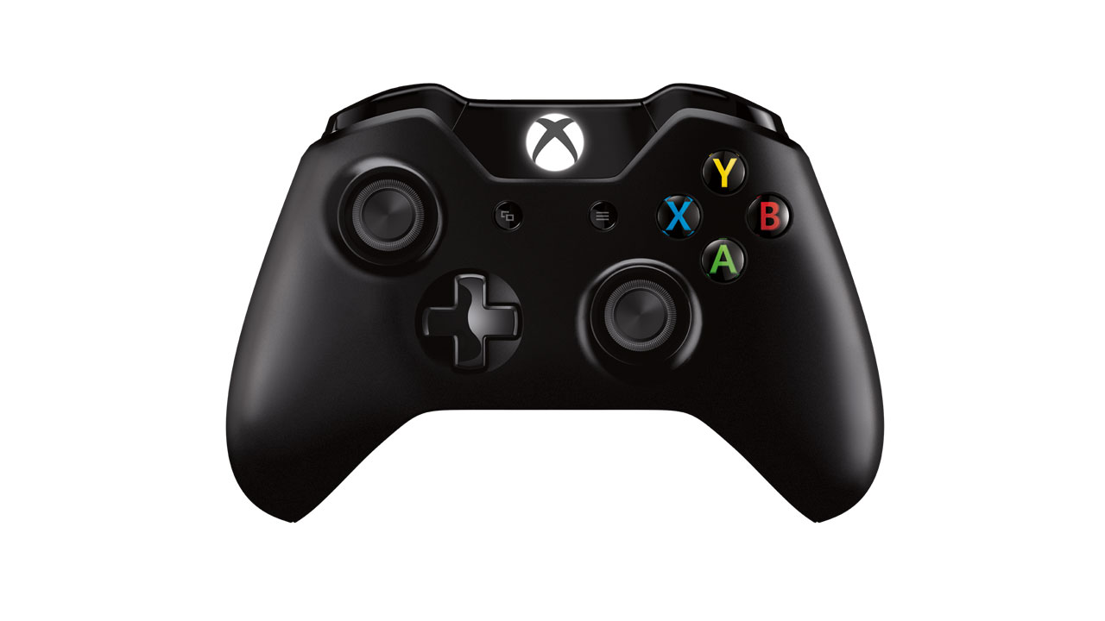

**Precise**

**Turbo**

**Stop Everything**

**Steer (L/R)**

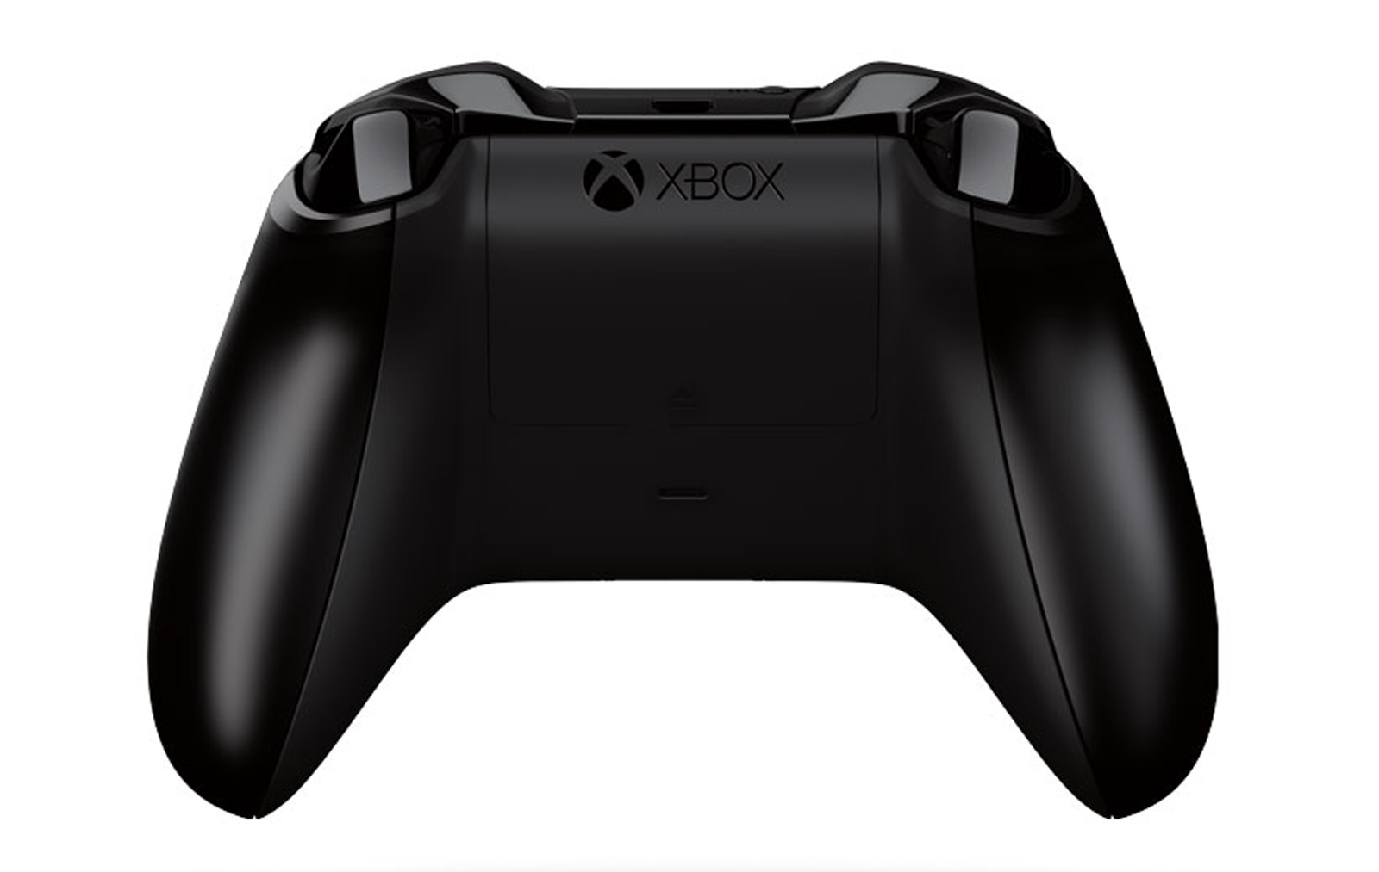

**Forward**

**Backward**